User Manual For Real Estate Database Application

# Basic Operations:

1. How to compile and execute?

Execute cmd.exe,

Input:

javac REInformation.java

java REInformation

2. How to login?

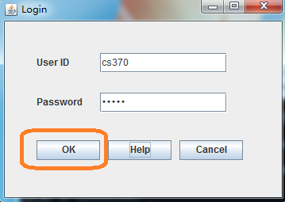

With login window, input:

User ID: cs370

Password: cs370

Press "OK" to enter main window of software.

3. Where can I find user ID and Password for login?

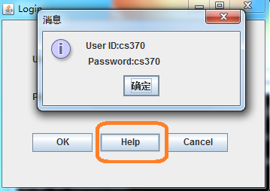

With login window, press "Help".

4. How to restore Data?

All commands that change data will be recorded on logfile.txt

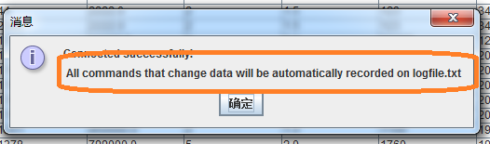

5. How to disconnect MYSQL and close software?

Click "X" at the upper right corner of window. The connection will be disconnected and the software will be closed.

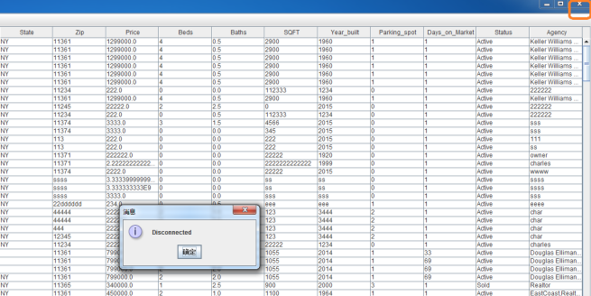

# Database Operations

6. How to search data?

Press" Search" on menu bar, then press "search" menu Item

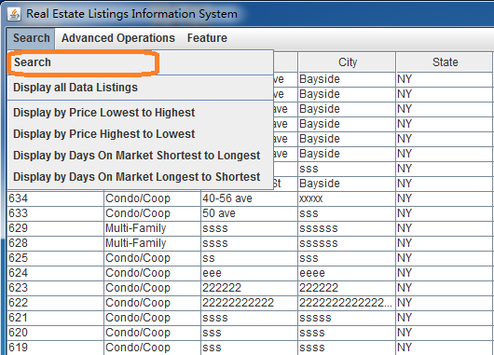

Search panel would come out. Fill in your search criteria, and press "Search" button.

Press "Cancel" to exit Search panel.

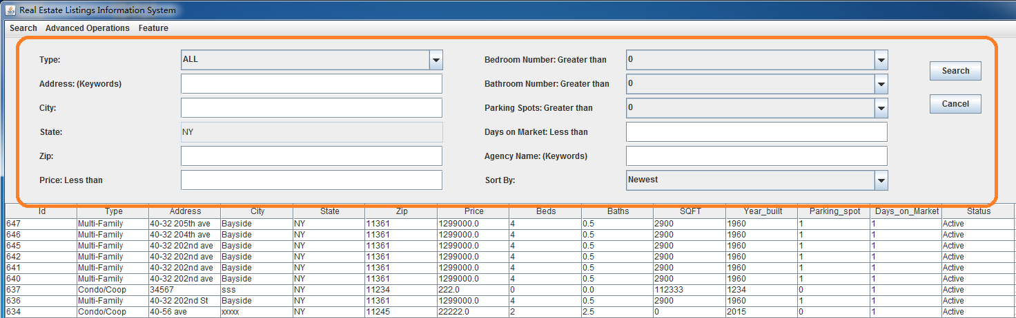

7. How to display all data?

Press" Search" on menu bar, then press "Display all Data Listings " menu Item.

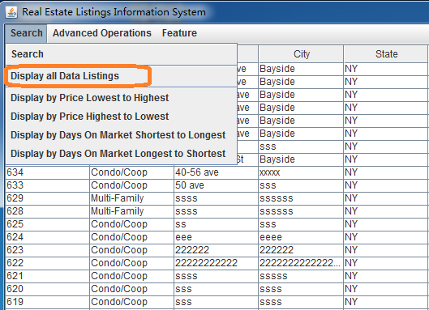

All data listings display in the table.

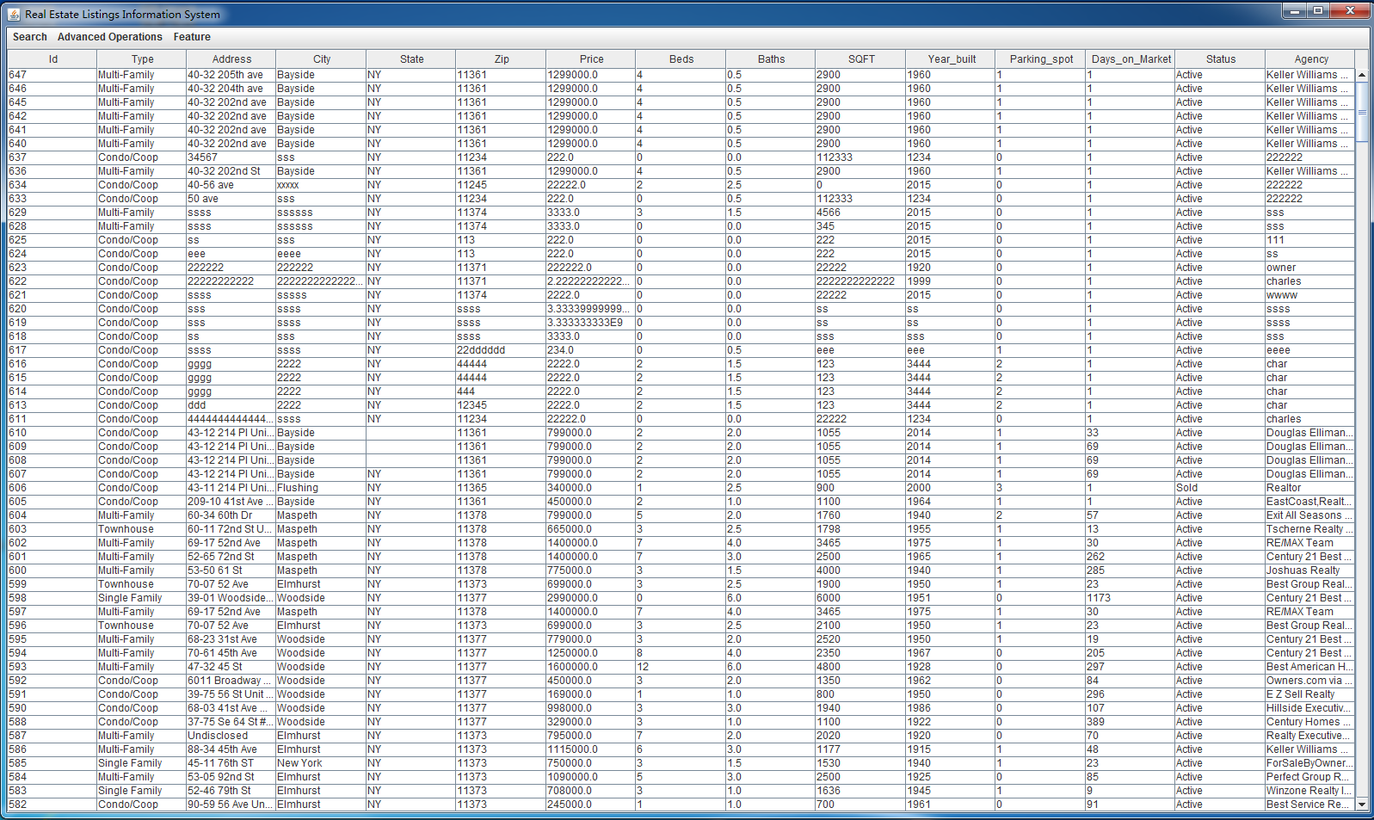

8. How to display listings by price lowest to highest?

Press" Search" on menu bar, then press "Display by Price Lowest to Highest " menu Item.

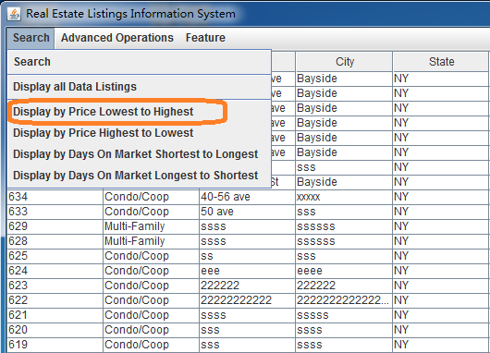

9. How to display listings by price highest to lowest?

Press" Search" on menu bar, then press "Display by Price Highest to Lowest " menu Item.

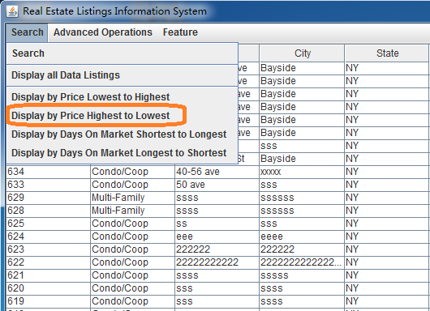

10. How to display listings by days on market shortest to longest?

Press" Search" on menu bar, then press "Display by Days on Market Shortest to Longest " menu Item.

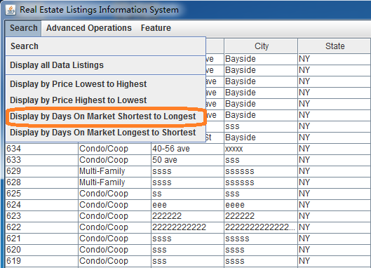

11. How to display listings by days on market longest to shortest?

Press" Search" on menu bar, then press "Display by Days on Market Longest to Shortest " menu Item.

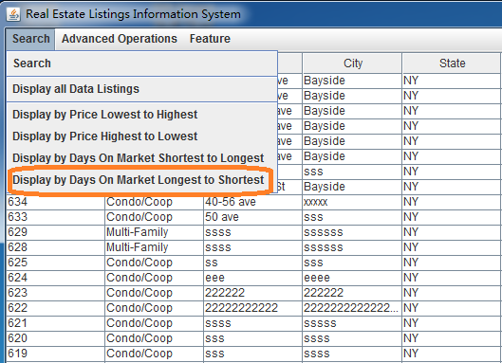

12. How to insert listing?

Press "Advanced Operations" on menu bar, then press "Insert" menu item.

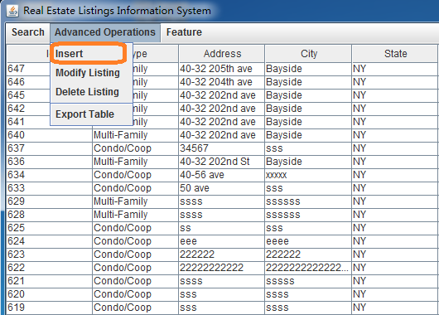

Insert Panel would come out. Fill in all spaces and press "Insert" to insert one listing.

Press "Cancel" to exit Insert panel.

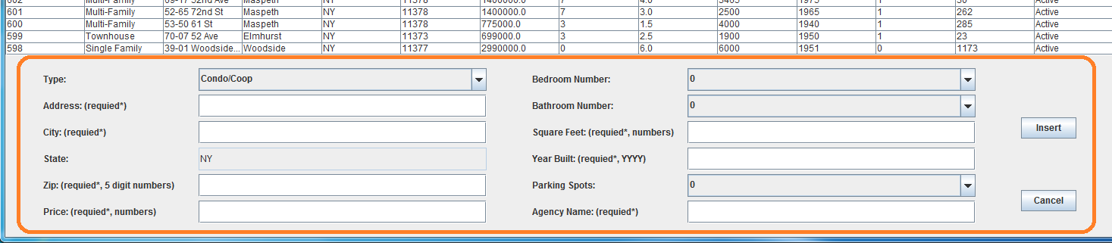

13. How to modify data?

Press "Advanced Operations" on menu bar, then press "Modify Listing" menu item.

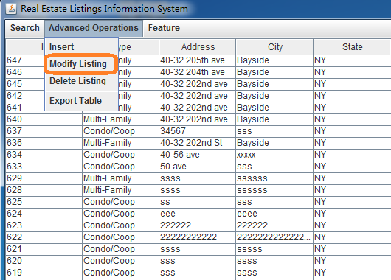

Modify panel would come out. Click listing on the table to choose listing needed to be modified. Fill in modified data and press "Modify" button.

Press "Cancel" to exit Modify panel.

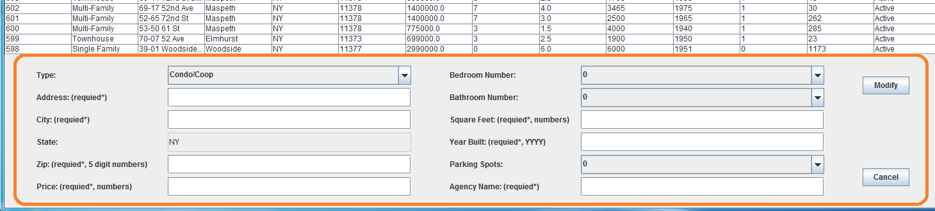

14. How to delete data?

Press "Advanced Operations" on menu bar, then press "Delete Listing" menu item.

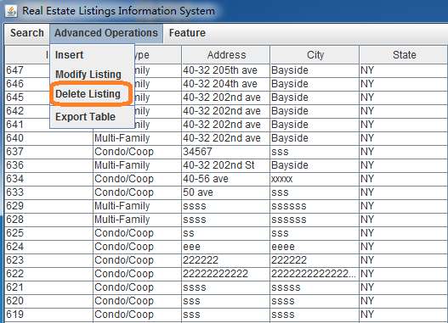

Delete panel would come out. Click listing on the table to choose listing needed to be deleted. Confirm data selected and press "Delete" button.

Press "Cancel" to exit Delete panel.

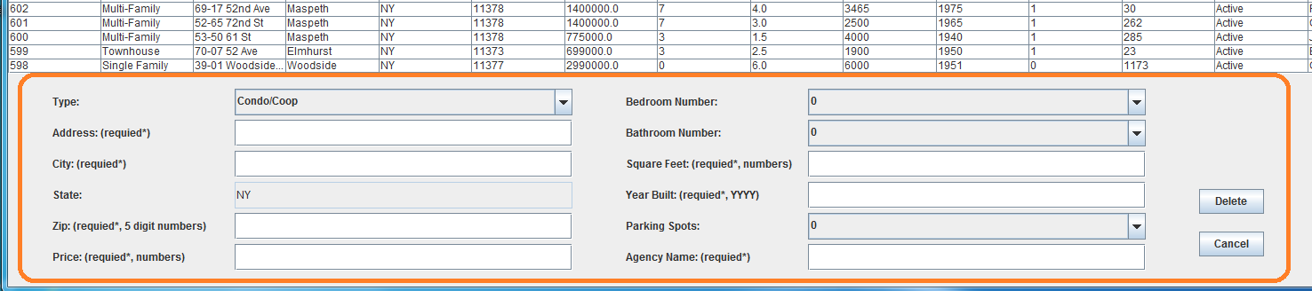

15. How to export data in the table?

Press "Advanced Operations" on menu bar, then press "Export Table" menu item.

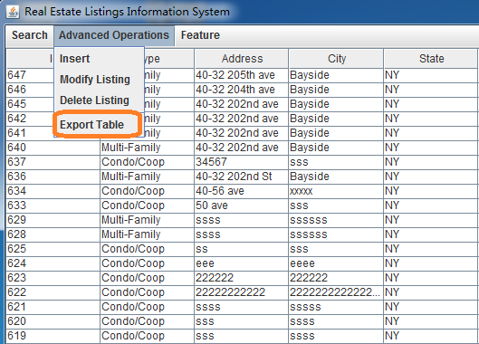

Choose file window would come out. Input desired txt file name and press "save".

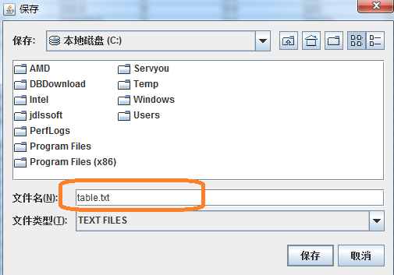

# Feature of this software

16. How to Search internet?

Press "Feature" on menu bar, then press "Search Internet" menu item.

The search internet panel would come out. Input searching key words, and press "Search" button. The result panel would display web links with web page containing corresponding keywords.

